Ex: No: STUDENT INFORMATION SYSTEM
Date:
AIM:
To Design ,Implement and Test the Student Information System described in the given problem statement .
PROBLEM STATEMENT:
The student management system can handle all the details about a student . The details include college details, course details , students personal details , academic details etc.., The student management system is an automated version of manual student management system . The student management system allows authorized members to access the record of academically registered students. This helps in maintaining the database of the students in any educational organization. we can easily access any student’s information anytime and can be kept safely for long period of time without any damage .
1. Administrator
2. User

Administrator :
SMS is managed by Administrator. Administrator has to update and monitor the registered student details , provide register number for all the students , generate hall tickets for all the students , evaluate examination marks and allocate fees for each courses etc..,

Users :
User can only see their personal details , fees details , examination schedule , mark sheets , download hall tickets for each semester.
- To update the information that is essential to transmit to the users.
- To have a centralized control over the records of the students , departments , teachers , staffs , library , etc.., and monitor the changes in these records .

USECASE DIAGRAM:

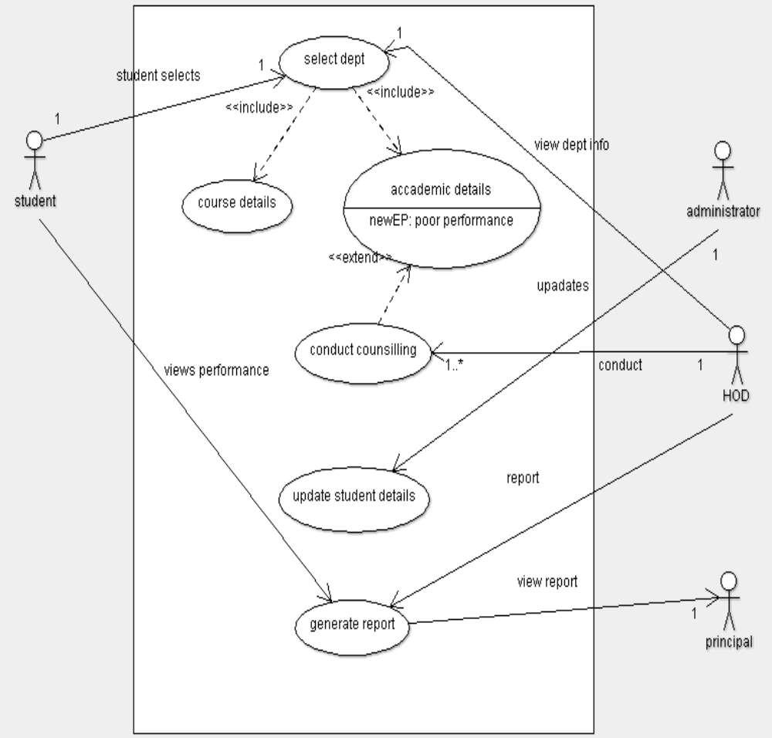

CLASS DIAGRAM:

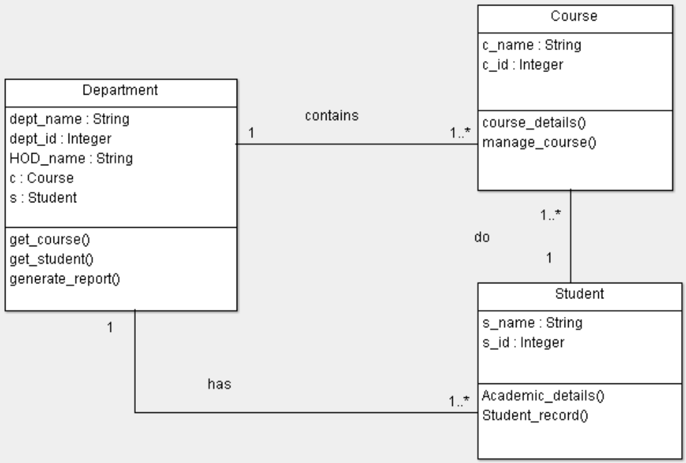

SEQUENCE DIAGRAM:
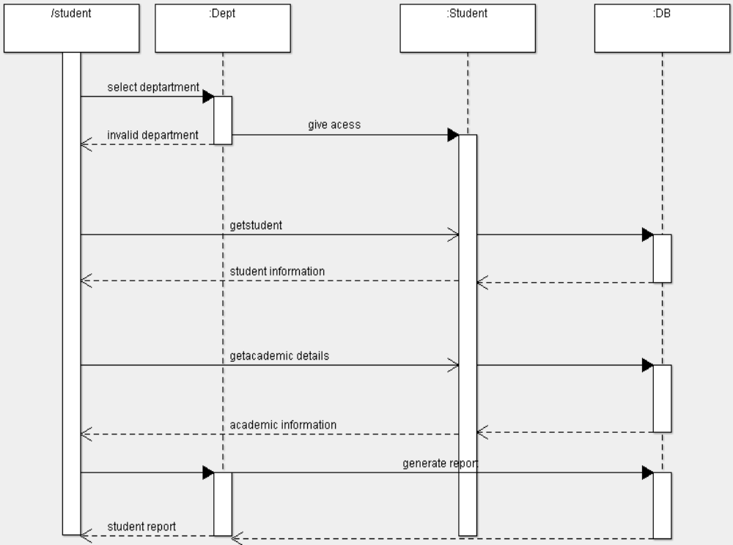

ACTIVITY DIAGRAM:
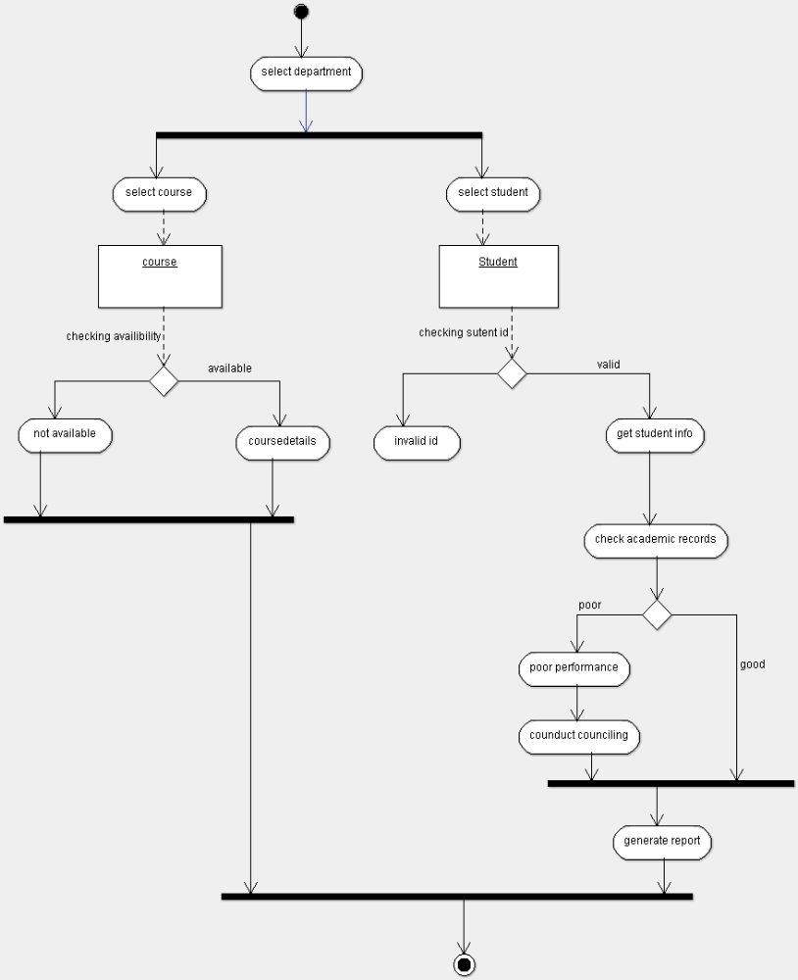

STATE CHART DIAGRAM:

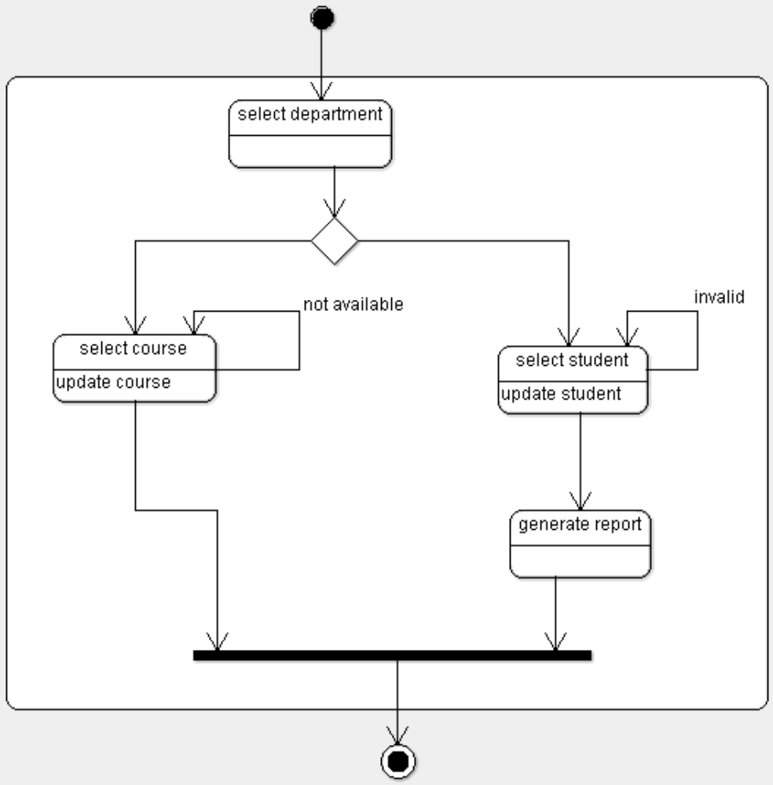

COMPONENT DIAGRAM:
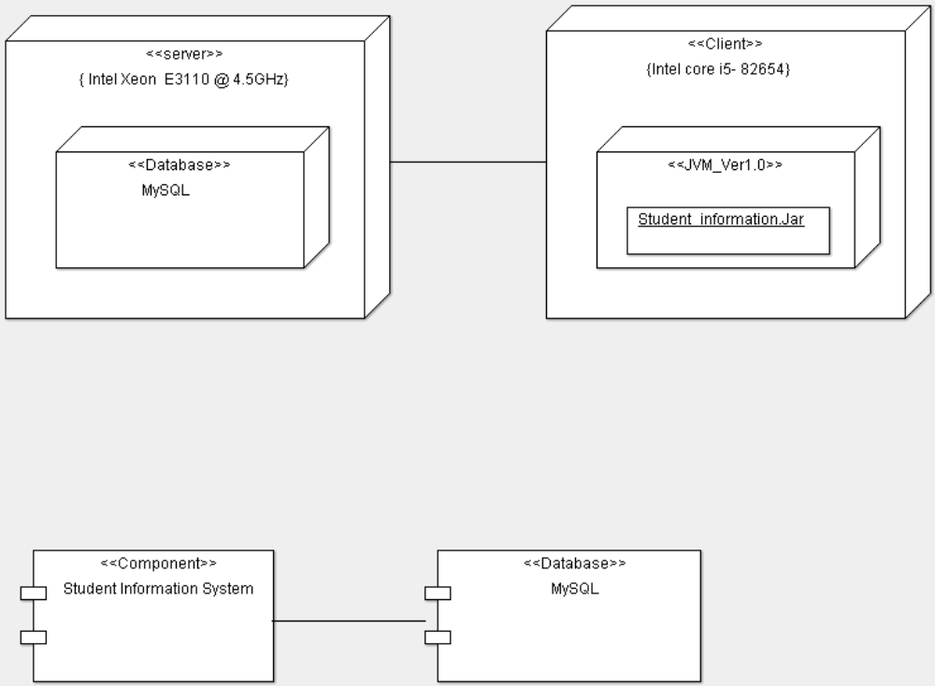

DEPLOYMENT DIAGRAM:

IMPLEMENTATION & TESTING

Student information system :
import static java.lang.System.exit;
import java.util.*;

public class Studentinformationsystem extends Department {

public static void main(String[] args) {

Scanner sc = new Scanner(System.in);
int e;
do
{
System.out.println("**********STUDENT INFORMATION SYSTEM**********");
System.out.println("SELECT DEPARTMENT");
System.out.println("1.CSE \n2.ECE \n3.MECH");
int n = sc.nextInt();
switch(n)
{
case 1 : Department d = new Department();
System.out.println("Welcome to CSE portal");
System.out.println(" 1. Course \n 2. Student ");
int b = sc.nextInt();
switch(b)
{

case 1 : d.get_course();

break;

case 2 : d.get_student();
break;

}
break;

case 2 : Department d1 = new Department();
System.out.println("Welcome to ECE portal");
System.out.println(" 1. Course \n 2. Student ");
int c = sc.nextInt();
switch(c)
{
case 1 : d1.get_course();
break;

case 2 : d1.get_student();
break;

}
break;
case 3 : Department d2 = new Department();
System.out.println("Welcome to MECH portal");
System.out.println(" 1. Course \n 2. Student ");
int f = sc.nextInt();
switch(f)
{
case 1 : d2.get_course();
break;

case 2 : d2.get_student();
break;

}
break;
default :

System.out.println("Department not available! .wrong selection..");
break;

}
System.out.println(" press 1 for home page");
e = sc.nextInt();
}while( e ==1);
exit(0);
}
}

Department:

public class Department extends Course {

public String dept_name;

public Integer dept_id;
public String HOD_name;
public Course c = new Course();
public Student s = new Student();

public void get_course() {
System.out.println("Enter the any 3 course to apply");
c.manage_course();
System.out.println("Course details");
c.course_details();
}

public void get_student() {
System.out.println("Enter the student details to check his academic scores");
s.Student_record();
System.out.println("Academic details");
s.Academic_details();

System.out.println("Generating report...\n");
System.out.print("Report: ");
s.generate_report();
}
}
Course :
import java.util.*;
public class Course extends Student {
public String c_name []=new String[4];
Scanner s1 = new Scanner(System.in);
public void course_details() {
System.out.println("\n press the order of your course to get details");
int g= s1.nextInt();
switch(g)
{
case 1 :
System.out.println("Course Name : "+c_name[1]);
System.out.println(" DESCRIPTION:\n Duration of this 4 month course.\n It consist of important topics along with hands on practice .\n course fees : 1200/- \n online quiz will be conducted at the end of every week . ");
break;

case 2 :
System.out.println("Course Name : "+c_name[2]);
System.out.println(" DESCRIPTION : \n Duration of this course is 8 weeks.\n Here you will learn core topics and their implementation.\n The course fees is 1200 INR .\n exam and certificates will be issued .");
break;
case 3 :
System.out.println("Course Name : "+c_name[3]);
System.out.println(" DESCRIPTION :\n Duration of this 6 month course.it consist of full core related topics and hands on practice along with 12 lab session \n certificates will be issued only when your final exam and assignment score atleast 50%.");
break;

default :
System.out.println("Sorry ! course not avilable");
break;
}

}

public void manage_course() {
System.out.print("enter the course names \n");
for(int i=1; i<4;i++ )
{
c_name[i]=s1.next();
}
System.out.println("\n Sort listing your courses...\n");
for(int i=1; i<4;i++ )
{
System.out.println("" + i +
""+ c_name[i]);
}
}
}

Student :

import static java.lang.Math.random;
import static java.lang.System.exit;
import java.util.*;
public class Student {
public String s_name;
public String s_id;
public int s ;
public int sum =0,count;
public float avg=0;
Scanner c = new Scanner(System.in);
public void Academic_details() {
System.out.println("Welcome "+s_name+"!");
System.out.println("SEMESTER \t GPA");
for(int i=1;i<s;i++)
{
Random r1 = new Random();
float p = (r1.nextInt(9)+1)+(r1.nextFloat());
if(p<=1 || p<=2)
p+=8;
else if(p<=3||p<=4)
p+=4;
else if (p<=5)
p+=4;

System.out.printf("" +i+ " \t %.2f ",p);
System.out.println("");
sum+=p;
}
avg=sum/s;
System.out.printf(" \n CGPA : %.2f ",avg);
System.out.println("");
}
public void Student_record() {
System.out.println("Enter student name :");
s_name=c.next();
System.out.println("Enter your 3 digit student ID");
s_id=c.next();
System.out.println("Enter current semester");
s = c.nextInt();
count =s_id.length();
if((count > 3)||(s>8))
{
System.out.println(" INVALID USER ");
System.out.println("Access Denied.");
exit(0);
}
}
public void generate_report()
{
if(avg<6)
{ System.out.println("you are in Second class degree.");
System.out.println(" poor performance , meet the HOD and attend counselling.improve your skills.");
}
else if(avg>=6 && avg <8)
System.out.println("you are in First class degree.work hard");
else
System.out.println("you are in First class degree with destinction . well done!");
}
}

Sample Output:

**********STUDENT INFORMATION SYSTEM**********
SELECT DEPARTMENT
1.CSE
2.ECE
3.MECH

1
Welcome to CSE portal
1. Course
2. Student

1
Enter the any 3 course to apply
enter the course names

DBMS
OOAD
C++

Sort listing your courses...

1 DBMS
2 OOAD
3 C++

Course details
press the order of your course to get details
2

Course Name : OOAD
DESCRIPTION :
Duration of this course is 8 weeks.
Here you will learn core topics and their implementation.
The course fees is 1200 INR .
exam and certificates will be issued .
press 1 for home page
1

**********STUDENT INFORMATION SYSTEM**********
SELECT DEPARTMENT
1.CSE
2.ECE
3.MECH
1
Welcome to CSE portal
1. Course
2. Student

2
Enter the student details to check his academic scores
Enter student name :
nishant
Enter your 3 digit student ID

316
Enter current semester
6
Academic details
Welcome nishant!
SEMESTER GPA
1 6.94
2 5.55
3 9.00
4 8.31
5 7.98

CGPA : 5.00
Generating report...

Report: you are in Second class degree.
poor performance , meet the HOD and attend counselling.
improve your skills.
press 1 for home page
0
Build successful.

TEST REPORT 1

Product : Student Information System
Use Case : Select Course

Test Case ID | Test Case / Action To Perform | Expected Result | Actual Result | Pass/Fail
- 1 | After Selecting The Course Portal Of The Department | Displays”Enter the 3 course that applied In Sort Listed Order” | Sort listing your courses…  1 DBMS  2 OOAD  3 C++ | Pass
 | After Selecting Particular Course. | Displays “Course Details” | Course Name : OOAD  DESCRIPTION :  Duration of this course is 8 weeks.  Here you will learn core topics and their implementation.  The course fees is 1200 INR . exam and certificates will be issued . | Pass
TEST REPORT 2

Product :Student Information System
Use Case : Academic Details

Test Case ID | Test Case / Action To Perform | Expected Result | Actual Result | Pass/Fail
 | CGPA > 6 | Displays “Report with  First class degree “ | Report :  “you are in first class . Well done.” | Pass
- 6 | CGPA<6 | Displays “Report with  Second class degree “ | Report :  “you are in Second class . Work hard ,attend the counseling” | Pass

TEST REPORT 3

Product : Student Information System
Use Case :Select Department

Test Case ID | Test Case / Action To Perform | Expected Result | Actual Result | Pass/Fail
 | If The Student Enter Invalid Department Id. | Display “Invalid Department” | Prints “Invalid Department” | Pass

